Clinical Assessment Tool for the Febrile Child 0-16 years
Out of hospital pathway-Luton & South Beds
Think ‘’could this be sepsis?’’ And refer to NICE guidelines on sepsis, recognition, diagnosis, early management if a child presents with fever and symptoms or signs that indicates possible sepsis.
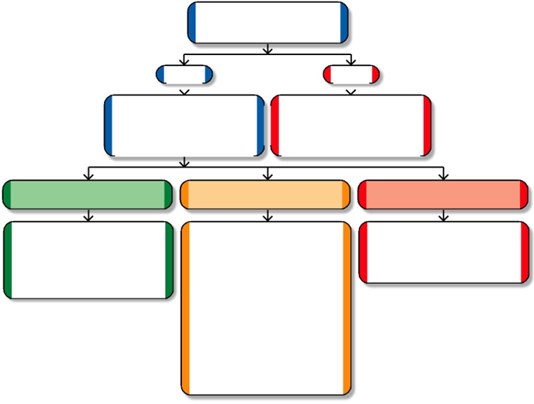
Do symptoms and/or signs suggest an immediately life-threatening illness?

 | No |  |  |  |  |  |  | Yes
Look for traffic light symptoms |  |  |  |  |  |  | Refer immediately to
and signs of serious illness |  |  |  |  |  |  | emergency medical care by
(see table 1) and symptoms |  |  |  |  |  |  | the most appropriate
and signs of specific diseases |  |  |  |  |  |  | means of transport
(see table 2 overleaf) |  |  |  |  |  |  | (usually 999 ambulance)

If all green features and no amber or red

If any amber features | If any red features
and no red

Provide parents/carers with discharge advice. Follow up by arranging an appropriate health care professional.
Children’s Rapid Response contact details: 07966025787

GP Urgent Connect:
01582 297297

If further advice is required contact the paediatric team via GP urgent connect in hours or bleep on call registrar out of hours (733)

- Provide parent/carer with written or verbal information on warning symptoms and accessing further healthcare.
- Arrange appropriate follow up to Rapid Response Team¹

- Liaise with other professionals to ensure parent/carer has direct access to further assessment.
- Refer to Children's Rapid Response if there are ongoing clinical concerns requiring review.

Send child for urgent assessment in a face-to-face setting within 2 hours

Table 1 Traffic light system for identifying likelihood of serious illness

 | Green-low risk | Amber- intermediate risk | Red- high risk
Colour | .Normal colour of skin,lips and tongue | .Pallor reported by parent/carer | .Pale/mottled/ashen/blue
Activity | • Responds normally to social cues  • Content/smiles  • Stays awake or awakens quickly  • Strong normal cry/not crying | • Not responding normally to social cues  • Wakes only with prolonged stimulation  • Decreased activity  • No smile | • No response to social cues  • Appears ill to a healthcare professional  • Unable to rouse or if roused does not stay awake  • Weak, high-pitched or continuous cry
Respiratory |  | • Nasal flaring  • Moderate Tachypnoea: (table 3)  • Oxygen saturation ≤ 95% in air  • Crackles | • Grunting  • Severe Tachypnoea (table 3)  • Moderate or severe chest indrawing  . Sp02 <92%/ new need for oxygen
Circulation and Hydration | • Normal skin and eyes  • Moist mucous membranes | . Reduced urine output  . Moderate Tachycardia (table 3)  . Poor feeding in infants  . Dry mucous membranes  . CRT≥ 3 seconds | • Reduced skin turgor  . Bradycardia  . Severe tachycardia (table 3)  . Not passed urine in last 18 hours
Other | • None of the amber or red symptoms or signs | . Age 3-6 months temperature ≥39◦C  . Fever for ≥5 days  . Swelling of a limb or joint  . Non-weight bearing/not using an extremity  . Rigors | . Age 0-3 months temperature ≥38◦C  . Non-blanching rash  . Bulging fontanelle  . Neck stiffness  . Status epilepticus  . Focal neurological signs  . Focal seizures
CRT: capillary refill time
*Some Vaccinations have been found to induce fever in children aged under 3 months.

Clinical Assessment Tool for the
Febrile Child 0-16 Years

Out of hospital pathway
Table 2 Symptoms and signs of specific diseases
Diagnosis to be considered | Symptoms and signs in conjunction with fever
Meningococcal disease | Non-blanching rash, particularly with one or more of the following:
 | • an ill-looking child |  | • CRT ≥ 3 seconds
 | • lesions larger than 2 mm in diameter (purpura) |  | • neck stiffness
Bacterial Meningitis¹ | • Neck stiffness |  | • Decreased level of consciousness
 | • Bulging fontanelle |  | • Convulsive status epilepticus
Herpes simplex encephalitis | • Focal neurological signs | • Focal seizures |  | • Decreased level of consciousness
Pneumonia | • Tachypnoea, measured as: |  | • Crackles in the chest
 | – 0–5 months – RR > 60 breaths/minute |  | • Nasal flaring
 | – 6–12 months – RR > 50 breaths/minute |  | • Chest indrawing
 | – > 12 months – RR > 40 breaths/minute |  | • Cyanosis
 |  |  | • Oxygen saturation ≤ 95%
Urinary tract infection (in children | • Vomiting | • Lethargy |  | • Irritability
aged older than 3 months)² | • Abdominal pain or tenderness | • Urinary frequency or dysuria |  | • Poor feeding
Septic arthritis/osteomyelitis | • Swelling of a limb or joint | • Non-weight bearing |  | • Not using an extremity
Kawasaki disease³ | Fever lasting 5 days or longer. Additional features may include:
 | • bilateral conjunctival injection without exudate |  | • oedema and erythema of hands and feet
 | • erythema and cracking of lips;strawberry tongue, or erythema of oral and pharyngeal mucosa
 | • cervical lymphadeonopathy |  | • polymorphous rash
CRT: capillary refill time | RR: respiratory rate

1 Classical signs (neck stiffness, bulging fontanelle, high-pitched cry) are often absent in infants with bacterial meningitis.

2 Urinary tract infection should be considered in any child aged younger than 3 months with fever. See ‘Urinary tract infection in children’.
3 Children under 1 may present with fewer clinical features of Kawasaki disease but may be more at risk of coronary artery abnormalities than older children.

Table 3
Age Tachypnoea (breaths/min) Tachycardia (beats/min)
 | Severe | Moderate | Severe | Moderate
<1 year | ≥60 | 50-59 | ≥160 | 150-159
1-2 years | ≥50 | 40-49 | ≥150 | 140-149
3-4 years | ≥40 | 35-39 | ≥140 | 130-139
5 years | ≥29 | 24-28 | ≥130 | 120-129
6-7 years | ≥27 | 24-26 | ≥120 | 110-119
8-11 years | ≥25 | 22-24 | ≥115 | 105-115
12 years and over | ≥25 | 21-24 | ≥130 | 91-130

This guidance is written in the following context:
This assessment tool is based on NICE guidance, which was arrived at after careful consideration of the evidence available. Healthcare professionals are expected to take it fully into account when exercising their clinical judgement. The guidance does not, however, override the individual responsibility of healthcare professionals to make decisions appropriate to the circumstances of the individual patient, in consultation with the patient and/or guardian or carer.
To be read in conjunction with Feverish Illness in Children, NICE guideline NG143. Oct 2023 v8.1

