 

­­**Bedfordshire, Luton and Milton Keynes Area Prescribing Committee (BLMK APC) – Formulary Subgroup**

**xx month 20xx**

**Agenda item xx**

**Title**

|  |
| --- |
| **What is the item?** |
| **Why is this being brought to the Formulary Subgroup?** |
| **What is the Formulary Subgroup being asked to discuss?** |
| **Who is bringing this to the Formulary Subgroup?** |
| **What are the options available?** |
| **Option 1:** |
| **Option 2:** |
| **Option 3:** |

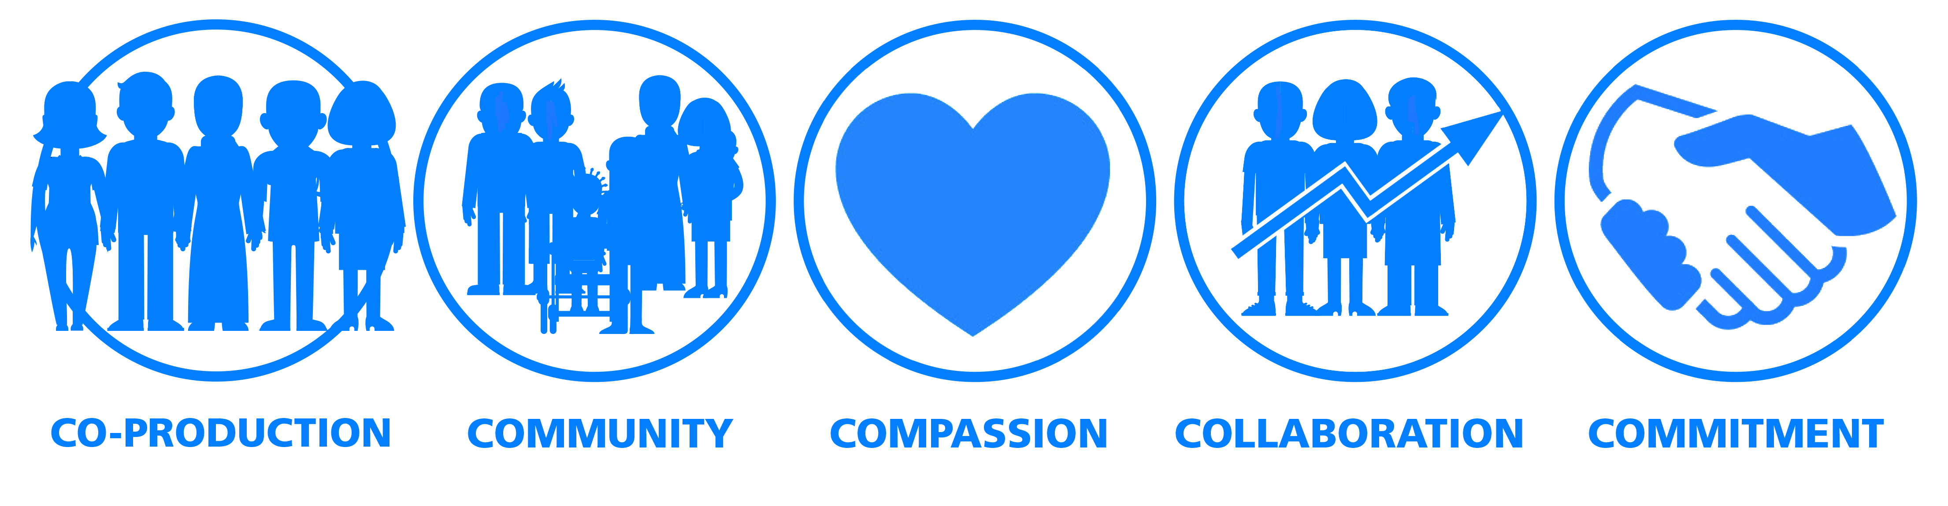

Bedfordshire, Luton and Milton Keynes (BLMK) Area Prescribing Committee (APC) and Formulary Subgroup Assessment against Ethical and Commissioning Principles

|  |
| --- |
| **Treatment assessed (Month and Year):** |
| **Formulary Subgroup/APC Recommendation**  TBC post meeting |
| 1. **Clinical Effectiveness**   e.g. according to national guidelines… |
| 1. **Cost Effectiveness**   e.g. most appropriate and cost- effective products have been recommended |
| 1. **Equity & Equality Impact Assessment\*** |
| Will this decision of the Formulary Subgroup/APC have an impact for patients or staff in regard to Equality, Inclusion and Human Rights legislation?  Such impacts (negative) could include:   * Restriction of a drug which could benefit those with certain conditions1,2   1NB Equality and Diversity is only one part of an assessment of the new drug/indication.  2It should be noted that where the BLMK APC/Formulary Subgroup is following national guidance, these have been developed with consultation and are required to have been subject to Equality Analysis and Due Regard. |
| **YES** If the proposal is likely to impact patients or staff, please set out those impacts and any mitigations that have been identified.  Examples include a process where the needs of exceptional cases can be met.  Should a significant impact be identified an EQIA should be completed |
|  |
| If **NO**, please state that the decision has been reviewed with regard to Equality, Inclusion and Human Rights and no issues have been identified. |
|  |
| 1. **Needs of the community**   e.g. prevalence and incidence of disease being treated? |
| 1. **Need for healthcare (incorporates patient choice and exceptional need**)   e.g. are there alternative therapies available or is this a completely new treatment option? |
| 1. **Policy drivers:** |
| 1. **Disinvestment:**  |  | | --- | | * + - How will this medicine help to address local health priorities?     - By using this medicine, what disinvestment in other medicines, interventions and services may be possible?     - How much would this save?     - Affordability considerations?     - Will this medicine help to address local health priorities? | |
| 1. **Environmental impact of decision (if applicable)** |

\***Equality Impact Assessment**

Where the implementation of the decision of the BLMK APC/Formulary Subgroup may impact on one or more equality group differently to others, an equality impact assessment will need to be completed if advised by the BLMK Equality and Diversity Lead.

|  |
| --- |
| **Protected Characteristics (under the Equality Act):-**  Age; Disability; Gender reassignment; Marriage & Civil Partnership (in employment only); Pregnancy & Maternity; Race; Religion & Belief; Sex; Sexual orientation; carers; other identified groups. |

B:\Primary Care\Medicines Optimisation\BLMK Commissioning\BLMK Formulary Sub Group\Paperwork\Current\BLMK Formulary Group Agenda Cover incorporating E and D Assessment Final Dec 2021.docx