Bedfordshire, Luton and Milton Keynes Area Prescribing Committee (BLMK APC) – Formulary Subgroup
[Enter date]
Agenda item X.X

This form is to be used to request addition of products that are not currently on the Formularies.
Full Formulary Application Form

Please see Appendix 1 for general guidance on how to complete and submit for discussion and approval.

Reason for application:

Guidance notes: What is the driver for this application? E.g. Is this in response to new guidance? Is it a new product to market? What is in place at the moment (if anything) that needs to change? Will this replace other products or be added as another option?

Click or tap here to enter text.

Service user impact:

Guidance notes: What is the prevalence of the disease being treated? How will this change address the need for treatment for service users in BLMK? Who will the service users be? Is this applicable to patients across Bedford, Luton AND Milton Keynes? Are there other options available to treat the disease? What are the expected patient numbers?

About the medicine(s)/device(s):

Guidance notes: Include here as much information as possible about the product. If there are any special considerations such as special storage requirements, short shelf life, complex reconstitution or known risks associated with the medicine please include it here.

Name:Click or tap here to enter text.

Strength/formulation/route:Click or tap here to enter text.

Dosage and duration of therapy: Click or tap here to enter text.

Pack size:Click or tap here to enter text.

Cost of pack (include source of information):Click or tap here to enter text.

Licensed or unlicensed product?:Click or tap here to enter text.

Dosage:Click or tap here to enter text.

Intended indication for use:Click or tap here to enter text.

Licensed or unlicensed indication:Click or tap here to enter text.

Monitoring requirements:Click or tap here to enter text.

Special considerations:Click or tap here to enter text.

Additional option or replacement of another product (state product):Click or tap here to enter text.
Place in therapy (e.g. 1st line / 2nd line/restricted to certain groups?):Click or tap here to enter text.

Evidence to support use of medicine for intended indication:

Guidance notes: Include in this section clinical evidence to support efficacy and/or safety. This could be NICE guidelines, statements from professional bodies, or evidence from clinical trials where applicable. Include reasons for benefit over other products available where applicable

References:

Cost Impact & patient numbers:

Guidance notes: How many patients are anticipated to be prescribed the medicine(s) across BLMK? How much will this cost? Will the change result in any cost savings elsewhere that will off-set the costs? Is this the most cost-effective option available? Include source of cost and whether VAT is included. Please also consider non-drug costs e.g. appointments, blood tests and consumables

Environmental impact:

Guidance notes: Does the change result in a positive impact on the environment? E.g. lower carbon footprint choice of inhaler, reduced plastic packaging, reduced single use packaging, re-useable product?

Equality impact:

Guidance notes: Will the decision have an impact for patients or staff in regard to Equality, Inclusion and Human Rights legislation? Such impacts (negative) could include: Restriction of a drug which could benefit those with certain conditions^{1,2}
¹NB Equality and Diversity is only one part of an assessment of the new drug/indication.
²It should be noted that where the BLMK APC/Formulary Subgroup is following national guidance, these have been developed with consultation and are required to have been subject to Equality Analysis and Due Regard.

If the proposal is likely to impact patients or staff, please set out those impacts and any mitigations that have been identified. Examples include a process where the needs of exceptional cases can be met.

Should a significant impact be identified an EQIA should be completed as advised by the BLMK Equality and Diversity Lead.

If no impact is envisaged, please state this below.

Protected Characteristics (under the Equality Act):
Age; Disability; Gender reassignment; Marriage & Civil Partnership (in employment only); Pregnancy & Maternity; Race; Religion & Belief; Sex; Sexual orientation; carers; other identified groups.

Stakeholder comments

Guidance notes: Include here any support/comments from stakeholders. Please attempt to obtain comment from those that will initiate, monitor and continue the therapy across the relevant settings e.g. secondary care / primary care / clinics

Short summary:

Guidance notes: Please provide a brief summary of key points in relation to the request

Proposed traffic light position on Formulary & nature of prescribing:

Guidance notes: See below for available designations. Who will be prescribing and monitoring the medicine?

Beds/Luton:
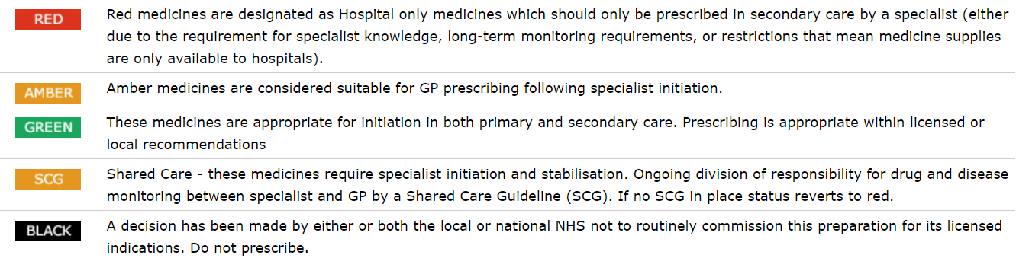

Milton Keynes:
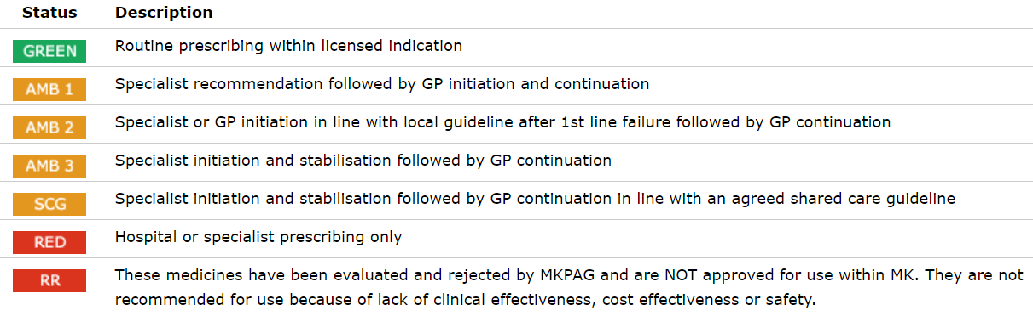

If high financial impact, signature of person with financial authority for the organisation is required:

Name of financial authority: | Click or tap here to enter text.
Job title: | Click or tap here to enter text.
Signature: | Click or tap here to enter text.
Date: | Click or tap here to enter text.
Contact information: | Click or tap here to enter text.
Declaration of Interest:

☐ I confirm that I have no conflicts of interest in relation to this application

☐ I have a conflict of interest to declare and enclose further information (see link)

See link to DOI form and information

Name: | Click or tap here to enter text.
Job title: | Click or tap here to enter text.
Signature: | Click or tap here to enter text.

Applicant Information:

Name: | Click or tap here to enter text.
Job title: | Click or tap here to enter text.
Signature: | Click or tap here to enter text.
Date: | Click or tap here to enter text.
Contact information: | Click or tap here to enter text.

Appendix 1: General guidance for completing the form:

- Please complete the form in full. Any blank sections will be sent back for completion by the applicant.
- It is expected that applications will have considered patients across the entire ICB to ensure equity of access for all patients within Bedfordshire, Luton and Milton Keynes to result in a harmonised approach within the system. Where an application covers only a selection of patients please state the reason for this.
- Primary and Secondary Care will inform each other immediately, via Chief Pharmacists / Formulary Pharmacists, where drug/device use has an effect on effect on patient pathways and/or if an application is relevant to their organisation.
- The application must reflect consensus from your directorate / Commissioning Support Unit / specialty / area.
- Each submission with high cost impact must be countersigned by a professional with accountability for clinical and budget management in your organisation. These are:

Clinical Management | Budget Management
MKUH NHS FT – Clinical Director of the relevant CSU | Finance Business Partner or Manager of the relevant CSU / Trust
BLMK ICB – Associate Director Medicines Optimisation
CNWL-MK / CCS / ELFT – Medical Director or Chief Pharmacist
Bedfordshire Hospitals – Clinical Director of the relevant CSU

- Submit completed forms to the place based lead pharmacist.

Place based lead Pharmacist contact details:

- Reena Pankhania - Reena.pankhania@ldh.nhs.uk Bedfordshire Hospitals NHS FT
- Janet Corbett - Janet.Corbett@mkuh.nhs.uk – Milton Keynes UH NHS FT
- Taiya Large – taiya.large1@nhs.net – BLMK ICB
- Anne Graeff – Anne.graeff@nhs.net – BLMK ICB
- Reginald Akaruese - r.akaruese@nhs.net – CNWL
- Saema Arain saema.arain3@nhs.net - ELFT
- Yolanda Abunga – yabunga@nhs.net – CCS

Submission to the BLMK Formulary Subgroup

- The BLMK Formulary Group meetings are scheduled for five dates over the year. Please see the BLMK Website for dates.
- Applications should normally be submitted 6 to 8 weeks before the meeting, whenever possible.
- Meetings are usually held in: February, April, June, September and November - exact dates within the month vary.
- The place-based Formulary Pharmacist / APC professional secretary will notify you of the date of the meeting when the application will be considered, subject to the receipt of all necessary information including that relating to sources of funding.
- You will be invited to attend to put forward the case for inclusion and answer any questions the group may have. If you are unable to attend, you may send a representative on your behalf or request to defer to a later meeting date.
- Submissions will be considered, at the discretion of the Chair of the BLMK Formulary Group, in the absence of the applicant if appropriate information is available at the time when the agenda and papers are prepared.
- Applicants will not be present when the BLMK Formulary Group/APC discusses its recommendation or decision.
- We suggest that you contact your organisation’s pharmacy/medicines management service before you complete this form, so that they may provide you with support and advice on the process.

Please email blmkicb.medsopt@nhs.net for further information regarding any of the above.

